Similar Game Analysis

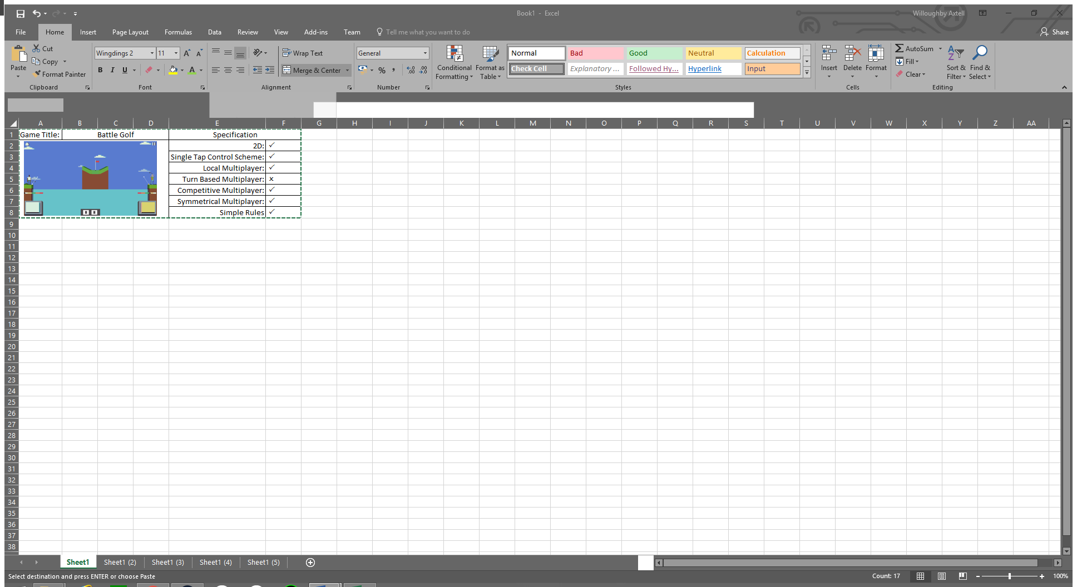

Battle Golf a simple 2D local multiplayer game, unlike our specification the game is not turn based however the game would function the same if it were turn based, the control scheme involves each player tapping their button once to set the angle of the shot and then once again to set the strength, the goal is to land the ball in the hole. This game creates a competitive atmosphere by using the scoreboard as well as the pacing, the scoreboard being constantly on display helps the players keep track of who is in the lead and allows the losing player to try harder to win and the winning player to try to prevent that, because of this a scoreboard may be useful in our game to create a competitive atmosphere.

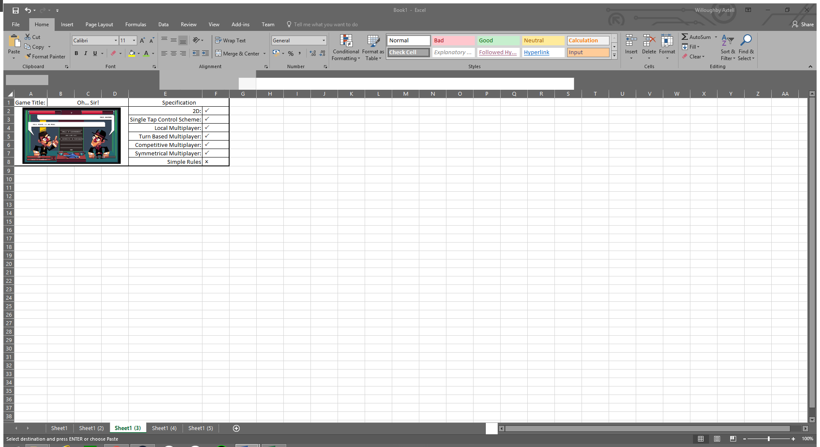

Oh… Sir! Is a more complex mobile game where players take turns in order to construct insults to deplete the opponent’s health bar, this game is significantly more complicated than our game should be however otherwise it would meet our game brief. The multiplayer in this game involves each player selecting part of a sentence in their turn and then moving onto the next player, after all words have been depleted or both sentences have been finished the round ends and the damage is calculated. Like Battle Golf this game uses a depiction of score to help the competitive atmosphere, however rather than a score in this it’s a health bar, this gives players a sense of urgency as when either player is low health the losing player will have to try harder to survive while the winning player will have to try to finish of their opponent.

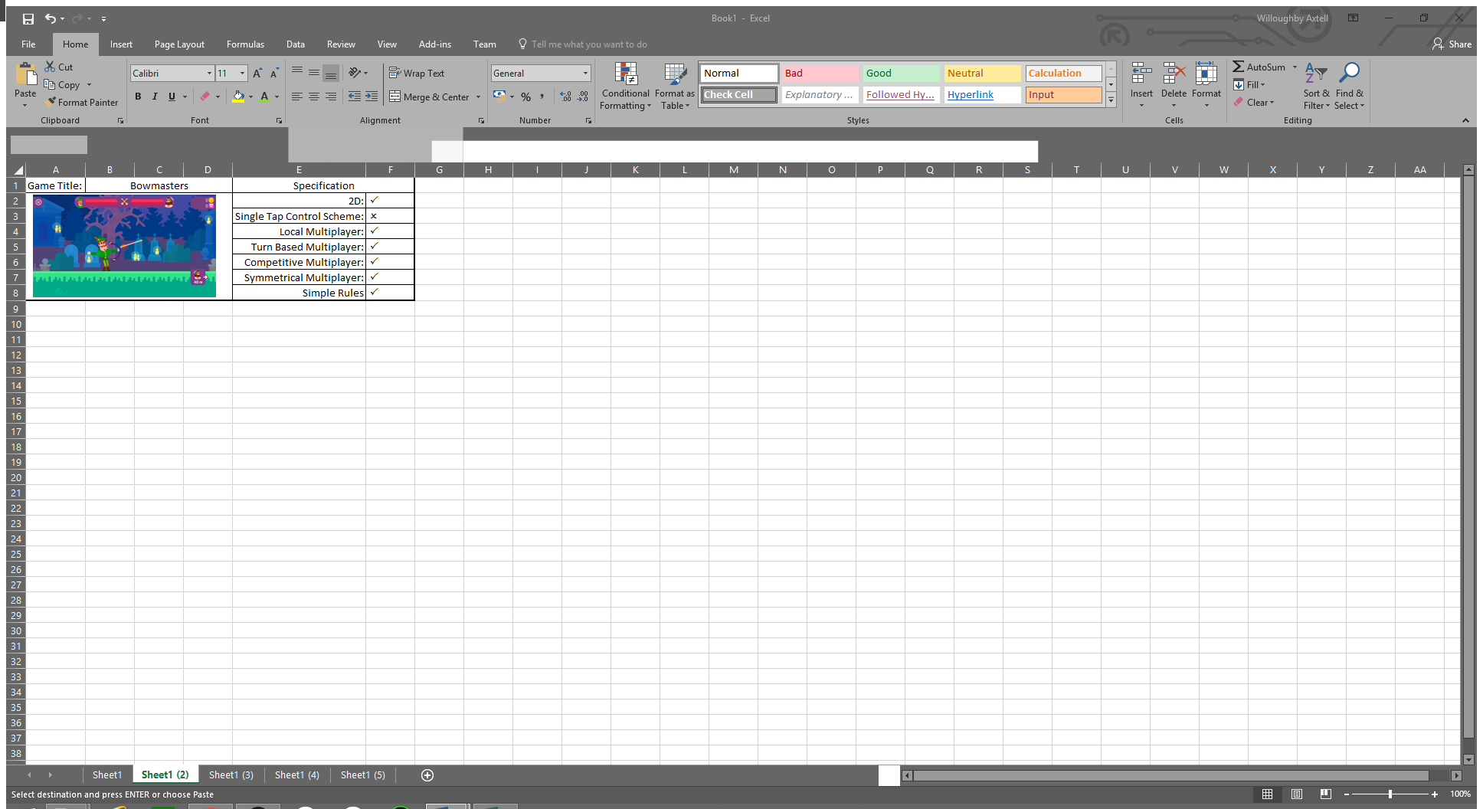

Bowmasters is another local multiplayer game where players compete to defeat the other player, Bowmasters control scheme is like Battle Golf’s where players control the angle and strength of a shot but in this game rather than using tapping the game uses a pullback mechanic. Just like Oh… Sir! this game uses health bars to create a competitive feeling, multiplayer in this game works by allowing each player to take one shot at the opponent in their turns, after they take a shot the other persons turn begins; this continues until one players health is fully depleted. This game also features a lot of violence unlike other games I have analysed this could restrict the target audience since many people do not like playing overly violent games, however of all the games I’ve analysed this game has been the most consistently popular and has remained in the top downloaded apps for longer than any of the other games.

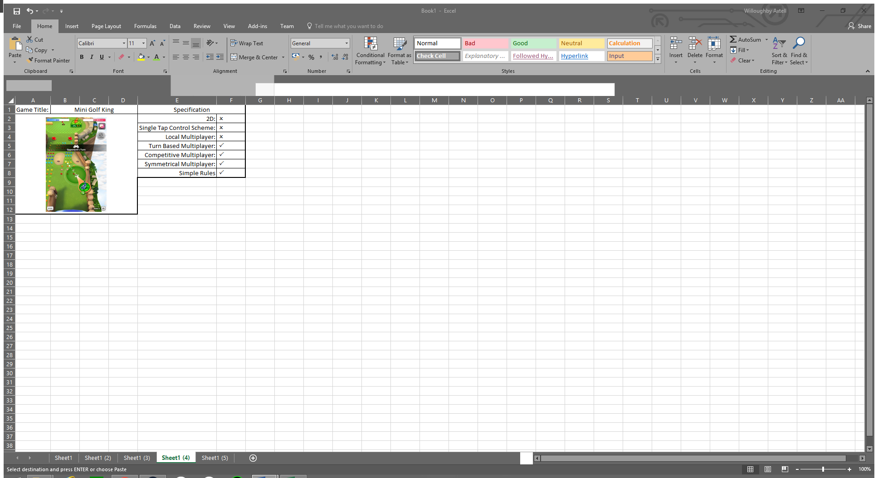

Mini Golf King is another game themed around golf, of all the games that I’ve analysed this one is the furthest from fitting the brief, however it would be fully possible for a game like this to be made that fits the brief, multiplayer in this game is very simple, a player takes a shot at attempting to get the ball in the hole and then their turn ends, this continues until one player gets the ball in the hole and then the losing player gets one more shot to attempt to tie the game or lose by a smaller margin, because of this feature this is the only game where the player who takes the first turn does not receive an advantage as the second player can still tie the game if they get the ball in the hole in the same number of turns. Unlike the other games this game does not feature a score board and the only way of working out who’s winning is by judging the distance, because of this; this game has little feeling of urgency and could be considered more calming then the other games.

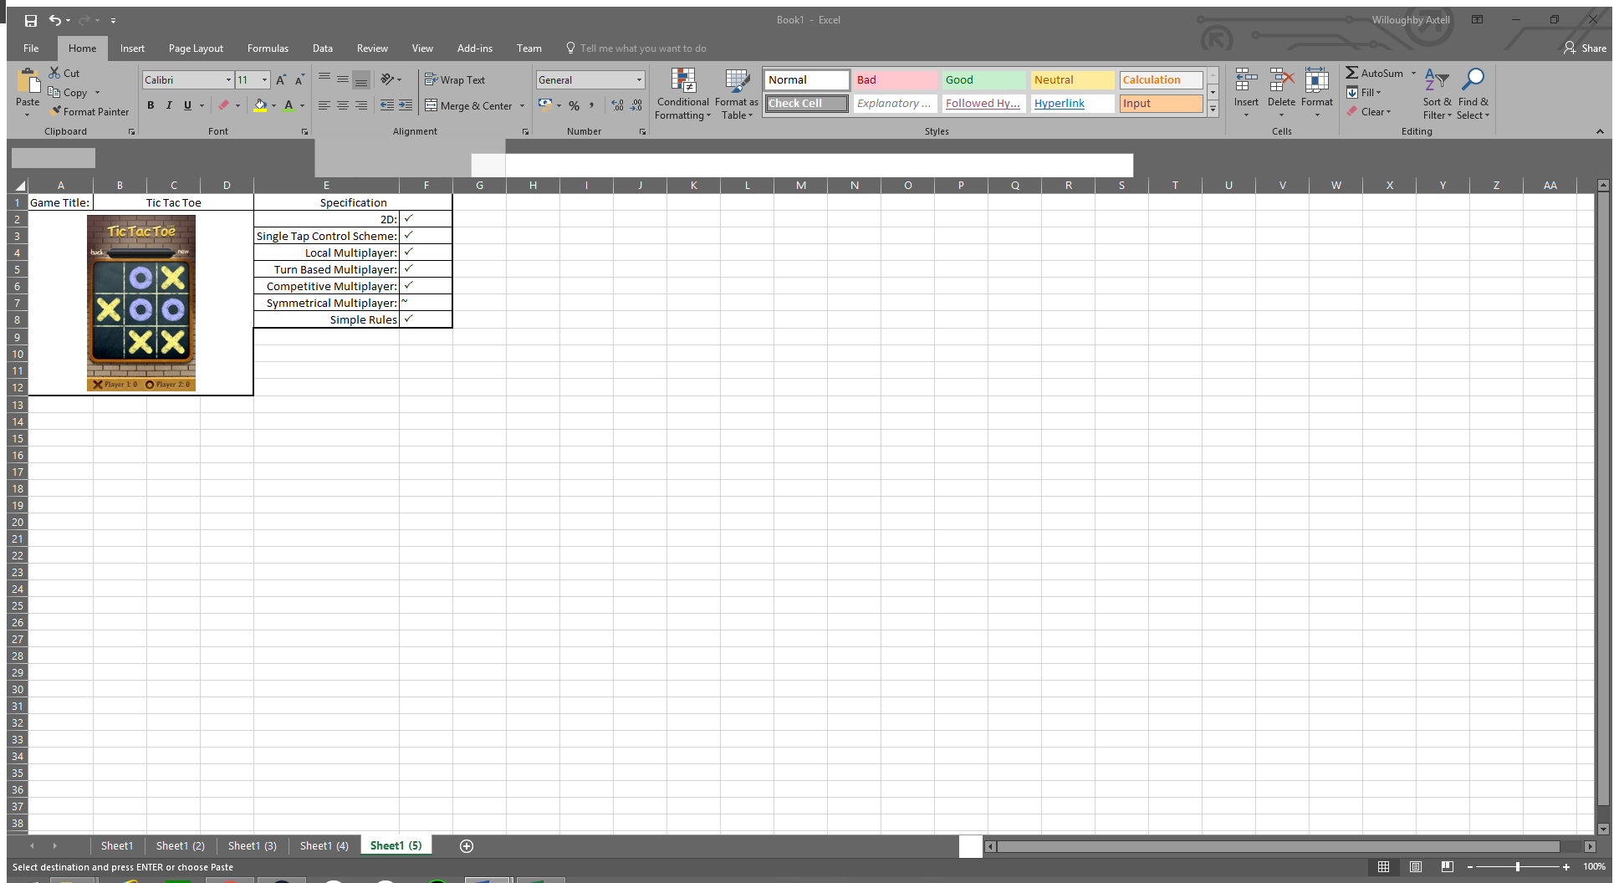

The last game I have chosen to analyse is Tic Tac Toe, this is a game based of the physical game of the same name (Aka Noughts and Crosses) it is also the game which meets our brief the best, the only thing it partially meets is symmetrical multiplayer due to the first player receiving a significant advantage but otherwise the game is balanced (This could be countered by swapping the first player between rounds) Multiplayer in this game involves each player taking turns to place their symbol in the board, a player wins by getting 3 of their symbols in a row, it is a tie if this becomes impossible. For individual matches this game features no scoring however for every round won the winning players score at the bottom will increase making playing multiple games more competitive.

Of all 5 games I’ve analysed one thing in particular stood out to me, that is that all the games uses unrealistic cartoony graphics, this type of art style will most likely be used in our game since it is optimized for mobile devices due to not being too complex and since all of these games use it; it must be popular with the casual gaming audience.